Simple demonstration to make sure we're all using the same good programming practice.

Step 1: Logic + Documentation
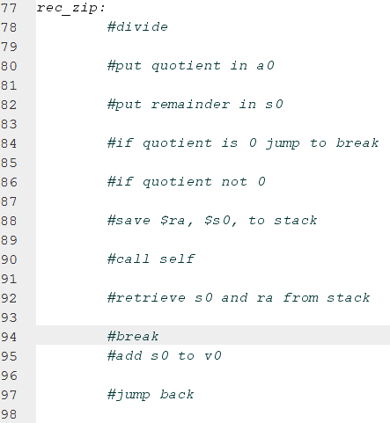
Step 2: Code + Polish
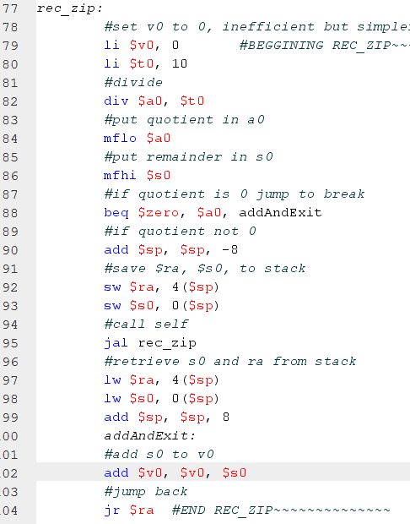

Benefits
ensures good documentation
allows revision/double checking of logic
makes keeping track of what to code next easier
breaks up work into very manageable chunks

